Q4:

The fraction of debt consolidation used to predict interest rate

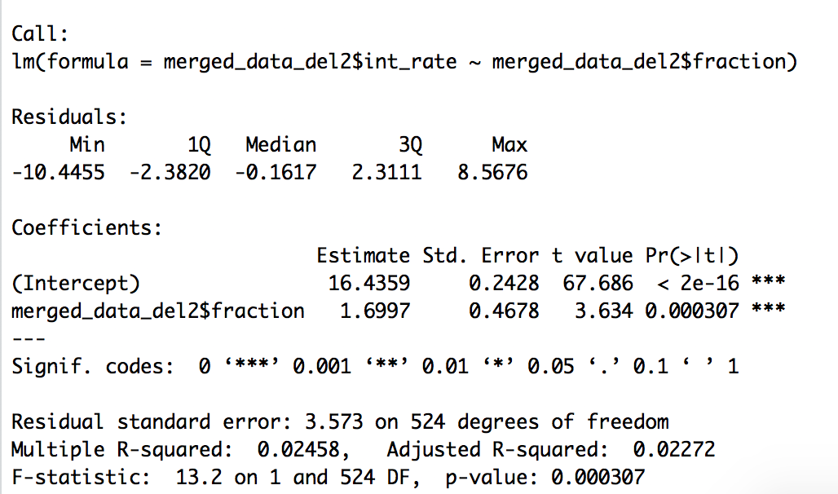

The fraction of debt consolidation used to predict interest rate
Coefficients | Estimate Std. | Std.Error | T Value | Pr(> | t | )
( Intercept ) | 16.4359 | 0.2428 | 67.686 | < 2e-16
Fraction of Debt Consolidation | 1.6997 | 0.4678 | 3.634 | 0.000307
Multiple R-Squared | 0.02458

The percentage of times never previously delinquent used to predict interest rate

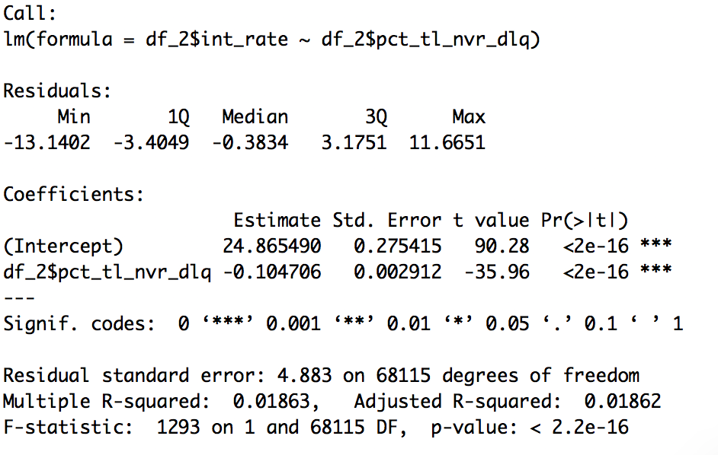

The percentage of times never previously delinquent used to predict interest rate
Coefficients: | Estimate | Std.Error | T value | Pr(> | t | )
(Intercept) | 24.865490 | 0.275415 | 90.28 | <2e-16
Percentage Never Delinquent | -0.104706 | 0.002912 | -35.96 | <2e-16
Multiple R- Squared | 0.01863

The percentage of winsorized tax liens used to predict interest rate

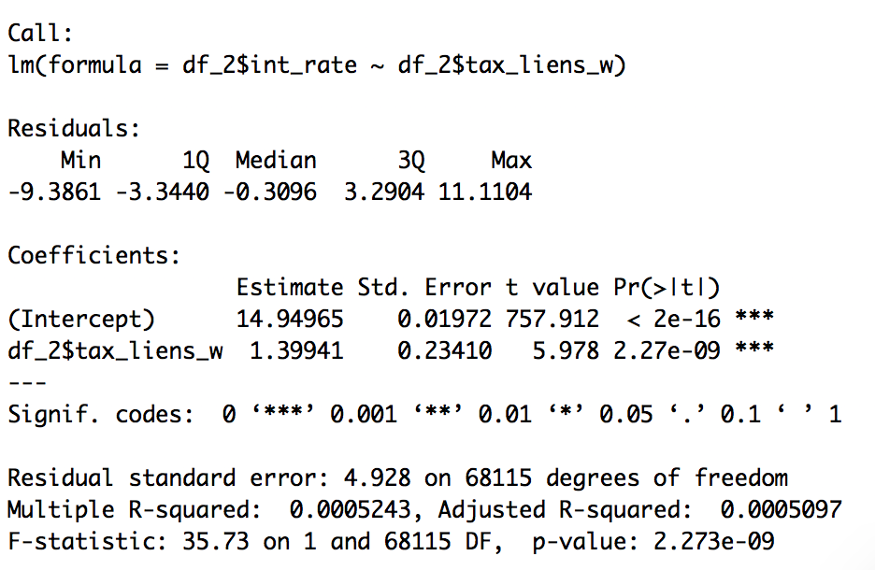

The percentage of winsorized tax liens used to predict interest rate
Coefficients | Estimate Std. | Std.Error | T Value | Pr(> | t | )
( Intercept ) | 14.94965 | 0.01972 | 757.912 | < 2e-16
Tax Liens - Winsorized | 1.39941 | 0.23410 | 5.978 | 2.27e-09
Multiple R-Squared | 0.0005243

The fraction of debt consolidation used to predict Loan Amount

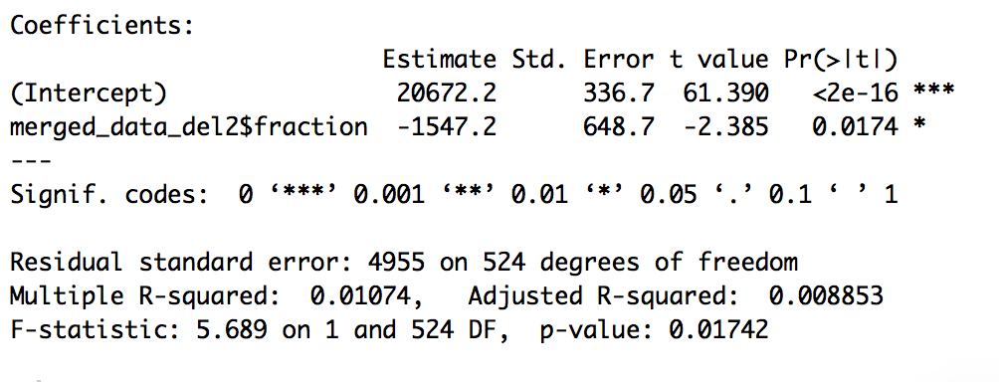

The fraction of debt consolidation used to predict loan amount
Coefficients | Estimate Std. | Std.Error | T Value | Pr(> | t | )
( Intercept ) | 20,672.2 | 336.7 | 61.390 | < 2e-16
Fraction of Debt Consolidation | -1547.2 | 648.7 | -2.385 | 0.0174
Multiple R-Squared | 0.01074

The percentage of times never previously delinquent used to predict Loan Amount
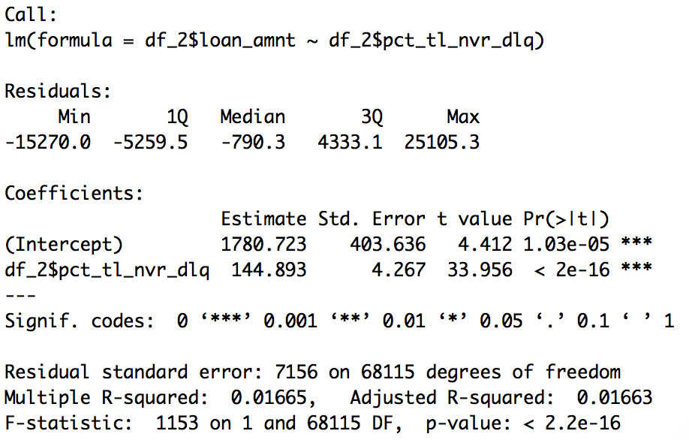

The percentage of times never previously delinquent used to predict Loan Amount
Coefficients: | Estimate | Std.Error | T value | Pr(> | t | )
(Intercept) | 1780.723 | 403.636 | 4.412 | 1.03e-05
Percent of Trades Never Delinquent | 144.893 | 4.267 | 33.956 | <2e-16
Multiple R- Squared | 0.01665

The percentage of winsorized tax liens used to predict Loan Amount
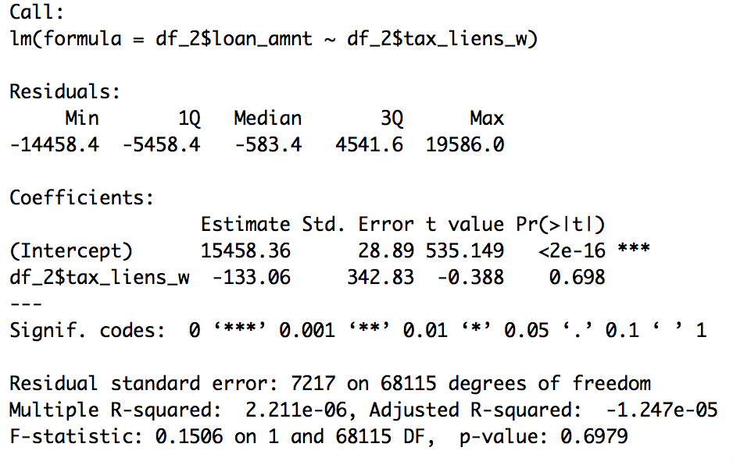

The percentage of winsorized tax liens used to predict Loan Amount
Coefficients | Estimate Std. | Std.Error | T Value | Pr(> | t | )
( Intercept ) | 15458.36 | 28.89 | 535.149 | < 2e-16
Tax Liens - Winsorized | 1.39941 | 342.83 | -0.388 | 0.698
Multiple R-Squared | 2.211e-06

Q5

A:

The term of the loan used to predict weather the loan is Defaulted on

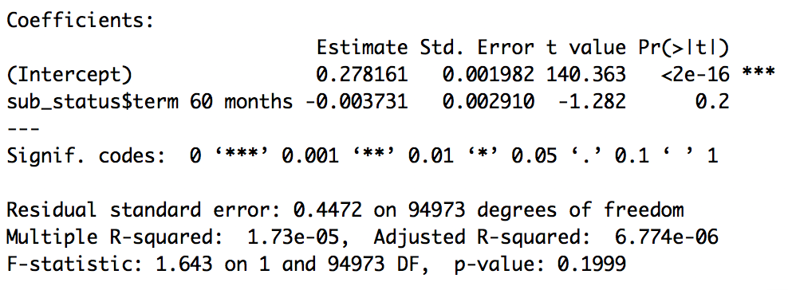

The term of the loan used to predict whether the loan is defaulted on
Coefficients: | Estimate | Std.Error | T value | Pr(> | t | )
(Intercept) | 0.278161 | 0.001982 | 140.363 | <2e-16
60 Month Term | -0.003731 | 0.002910 | -1.282 | 0.2
Multiple R- Squared | 1.73e-05

B:

Annual income winsorized used to predict loan amount

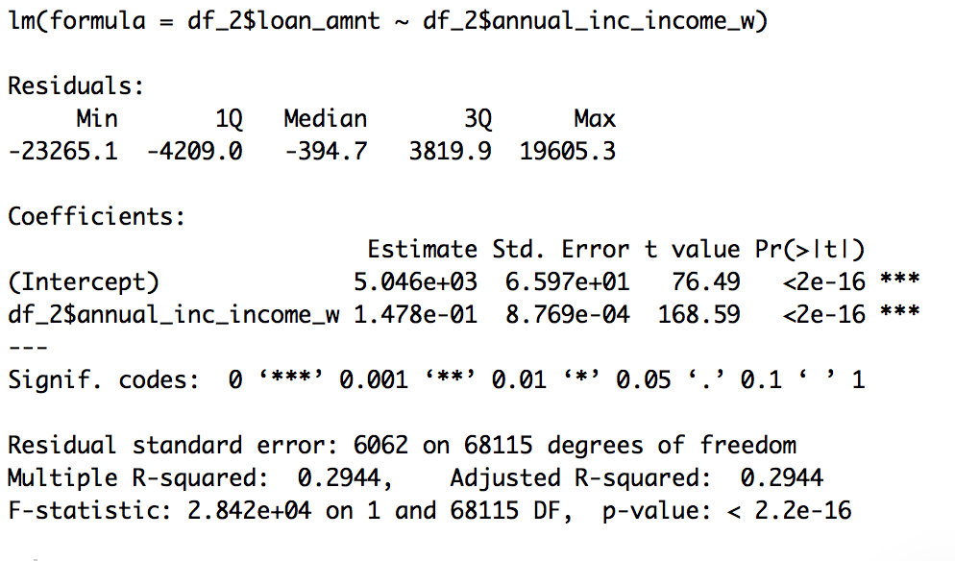

Annual income winsorized used to predict loan amount
Coefficients | Estimate Std. | Std.Error | T Value | Pr(> | t | )
( Intercept ) | 5.046e+03 | 6.597e+01 | 76.49 | < 2e-16
Annual Income - Winsorized | 1.478e-01 | 8.769e-04 | 168.59 | < 2e-16
Multiple R-Squared | 0.2944

Annual Income Winsorized used to predict Interest rate

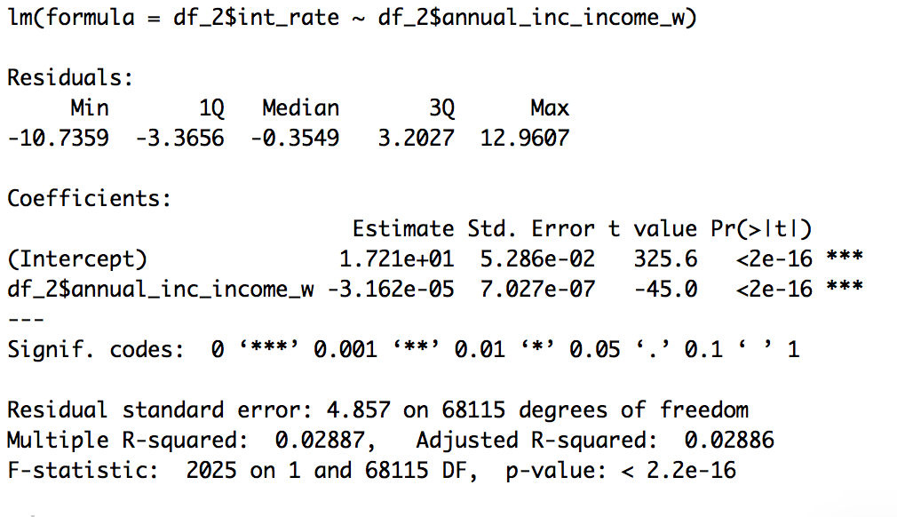

Annual Income Winsorized used to predict Interest rate
Coefficients: | Estimate | Std.Error | T value | Pr(> | t | )
(Intercept) | 1.721e+01 | 5.286e-02 | 325.6 | <2e-16
Annual Income- Winsorized | -3.162e-05 | 7.027e-07 | -45.0 | <2e-16
Multiple R- Squared | 0.02887

Annual Income Winsorized Interacting with Verification Status used to predict loan amount

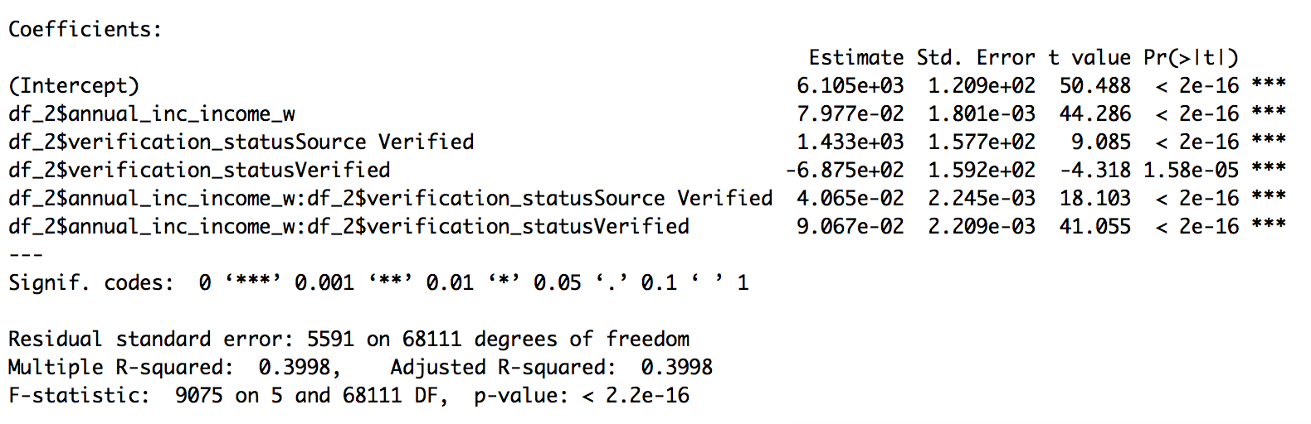

Annual Income Winsorized Interacting with Verification Status used to predict loan amount
Coefficients | Estimate Std. | Std.Error | T Value | Pr(> | t | )
( Intercept ) | 6.105e+03 | 1.029e+02 | 50.488 | < 2e-16
Annual Income - Winsorized | 7.977e-02 | 1.801e-03 | 44.286 | <2e-16
Status - Source Verified | 1.433e+03 | 1.577e+02 | 9.085 | <2e-16
Status - Verified | -6.875e+02 | 1.592e+02 | -4.318 | 1.58e-05
Annual Income- winsorized : Source Verified | 4.065e-02 | 2.245e-03 | 18.103 | <2e-16
Annual Income- winsorized : Verified | 9.067e-02 | 2.209e-03 | 41.055 | < 2e-16
Multiple R-Squared | .3998

Annual Income Winsorized Interacting with Verification Status used to predict interest rate
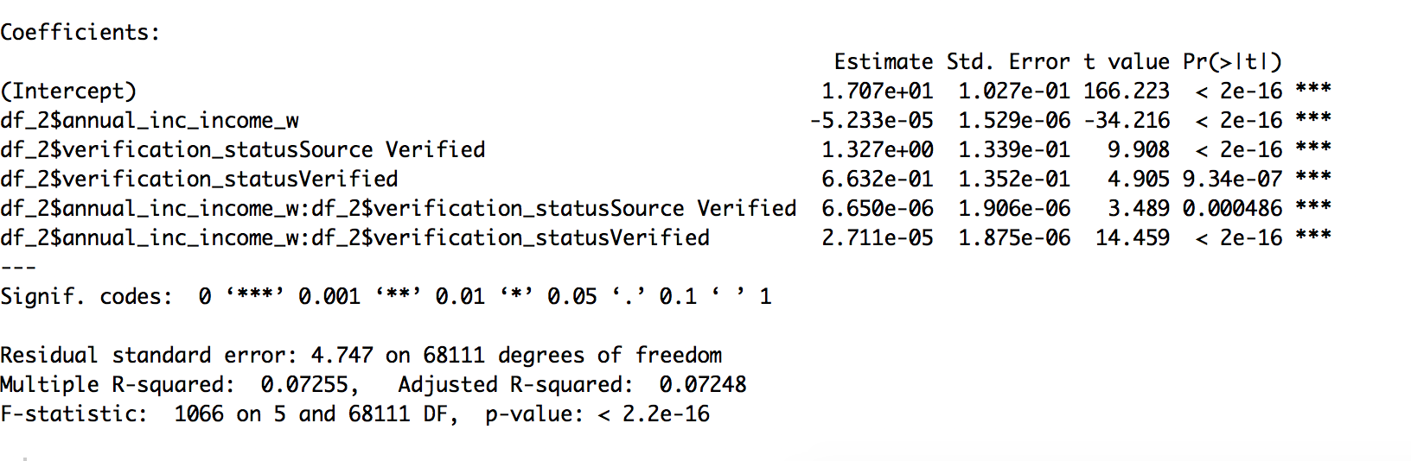

Annual Income Winsorized Interacting with Verification Status used to predict interest rate
Coefficients: | Estimate | Std.Error | T value | Pr(> | t | )
(Intercept) | 1.707e+01 | 1.027e-01 | 166.223 | <2e-16
Annual Income - Winsorized | -5.233e-05 | 1.529e-06 | -34.216 | <2e-16
Verification_statusSource_Verified | 1.327e+00 | 1.339e-01 | 9.908 | <2e-16
Verification_statusVerified | 6.632e-01 | 1.352e-01 | 4.905 | 9.34e-07
annual income$ verification status source Verified | 6.650e-06 | 1.906e-06 | 3.489 | 0.000486
Annual income $ verification status Verified | 2.711e-05 | 1.875e-06 | 14.459 | <2e-16
Multiple R- Squared | 0.07255

C:

Loans sub-grade used to predict whether it was charged off

NOTE: All sub grades are significant

D:

Percentage never delinquent and Subgrade used to predict whether the loan was charged off

NOTE: all sub grades are significant, percentage never delinquent is not!

Tax Liens percentage (because of aggregation) and Subgrade used to predict whether the loan was charged off

NOTE: all sub grades and Tax Liens were significant! Not multicollinear!

E:

Percentage never delinquent and Subgrade used to predict the interest rate

NOTE: All sub grades significant, pct delinquent P-Value of .0892 and thus sig at .1 level

Percentage never delinquent and Subgrade used to predict the loan amount

NOTE: All sub grades except A2 significant and pct. Delinquent

Tax Liens percentage (because of aggregation) and Subgrade used to predict the interest rate

NOTE: all sub grades and tax lien significant

Tax Liens percentage (because of aggregation) and Subgrade used to predict the loan amount

NOTE: Most sub grades and tax liens significant

F:
The purpose of the loan used to predict whether the loan was charged off
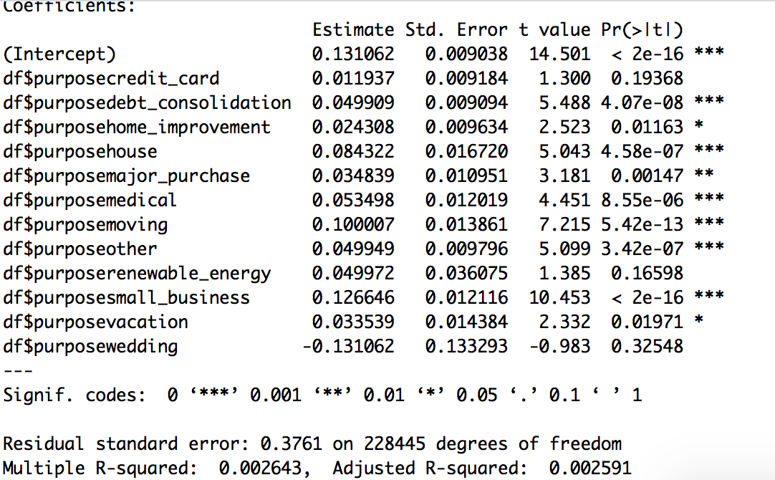
Annual Income Winsorized Interacting with Verification Status used to predict loan amount
Coefficients | Estimate Std. | Std.Error | T Value | Pr(> | t | )
( Intercept ) | 0.131062 | 0.009038 | 14.501 | < 2e-16
Purpose - Credit Card | 0.011937 | 0.009184 | 1.300 | 0.19368
Purpose - Debt Consolidation | 0.049909 | 0.009094 | 5.488 | 4.07e-08
Purpose - Home Improvement | 0.024308 | 0.009634 | 2.523 | 0.01163
Purpose - House | 0.084322 | 0.016720 | 5.043 | 4.58e-07
Purpose - Major Purchase | 0.034839 | 0.010951 | 3.181 | 0.00147
Purpose - Medical | 0.053489 | 0.012019 | 4.451 | 8.55e-06
Purpose - Moving | 0.100007 | 0.013861 | 7.215 | 5.42e-13
Purpose - Other | 0.049972 | 0.009796 | 5.099 | 3.42e-07
Purpose - Renewable Energy | 0.049972 | 0.036075 | 1.385 | 0.16598
Purpose - Small Business | 0.126646 | 0.012116 | 10.453 | < 2e-16
Purpose - Vacation | 0.033539 | 0.014384 | 2.332 | 0.01971
Purpose - Wedding | -0.131062 | 0.133293 | -0.983 | 0.3258
Multiple R-Squared | 0.002643

Part B

A:

The Lending Club annual income used to predict the IRS income
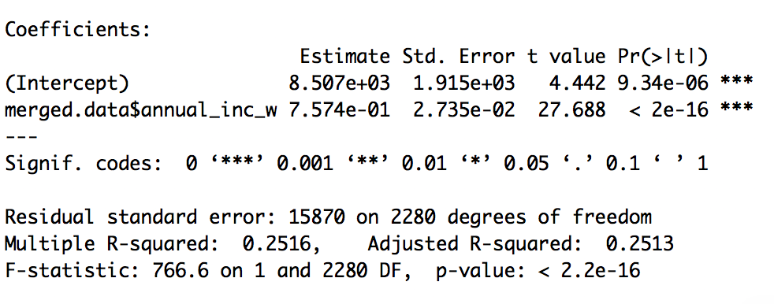

The Lending Club annual income winsorized used to predict the IRS income winsorized
Coefficients | Estimate Std. | Std.Error | T Value | Pr(> | t | )
( Intercept ) | 8.507e+03 | 1.915e+03 | 4.442 | 9.34e-06
Annual Income Winsorized | 7.574e-01 | 2.735e-02 | 27.688 | < 2e-16
Multiple R-Squared | 0.2516

The Lending Club annual income data winsordized and the verification status used to predict the IRS income data winsorized

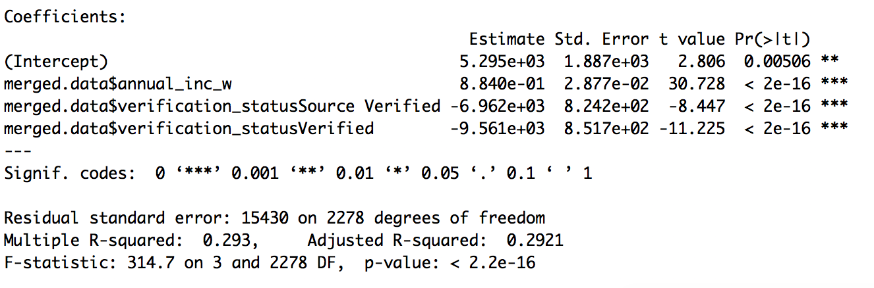

The Lending Club annual income data winsordized and the verification status used to predict the IRS income data winsorized
Coefficients | Estimate Std. | Std.Error | T Value | Pr(> | t | )
( Intercept ) | 5.295e+03 | 1.887e+03 | 2.806 | 0.00506
Annual Income  (Winsordize) | 8.840e-01 | 2.877e-02 | 30.728 | < 2e-16
Verification Status  Source Verified | -6.962e+03 | 8.242e+02 | -8.447 | < 2e-16
Verification Status  Verified | -9.561e+03 | 8.517e+02 | -11.225 | < 2e-16
Multiple R-Squared | 0.293

The Lending Club annual income data winsordized interacting with the verification status used to predict the IRS income data winsorized

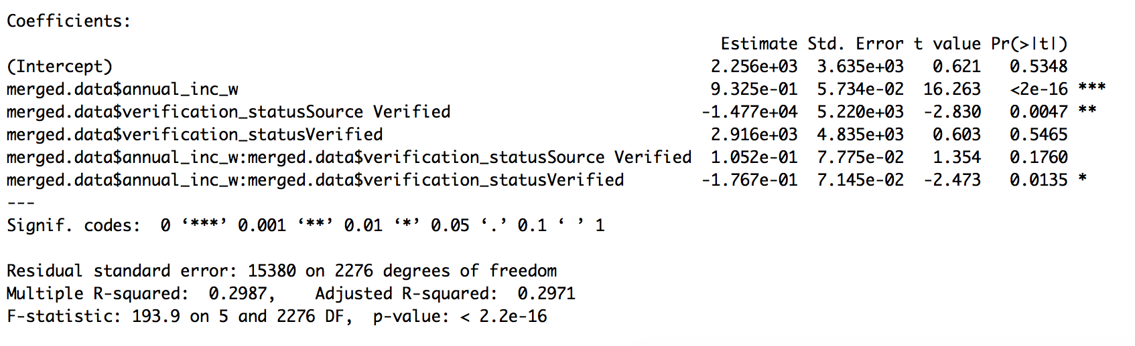
The Lending Club annual income data winsordized interacting with the verification status used to predict the IRS income data winsorized
Coefficients | Estimate Std. | Std.Error | T Value | Pr(> | t | )
( Intercept ) | 2.256e+03 | 3.635e+03 | 0.621 | 0.5348
Annual Income  (Winsordized) | 9.325e-01 | 5.734e-02 | 16.263 | < 2e-16
Verification Status  (Source Verified) | -1.477e+03 | 5.220e+03 | -2.830 | 0.0047
Verification Status  (Verified) | 2.916e+03 | 4.835e+03 | 0.603 | 0.5465
Annual Income$  Verification Status  (Source Verified) | 1.052e-01 | ^{7.775e-02} | 1.354 | 0.1760
Annual Income $  Verification Status  (Verified) | -1.767e-01 | 7.145e-02 | -2.473 | 0.0135
Multiple R-Squared | 0.2987

C:

Binned IRS data used to predict Lending Club income winsorized

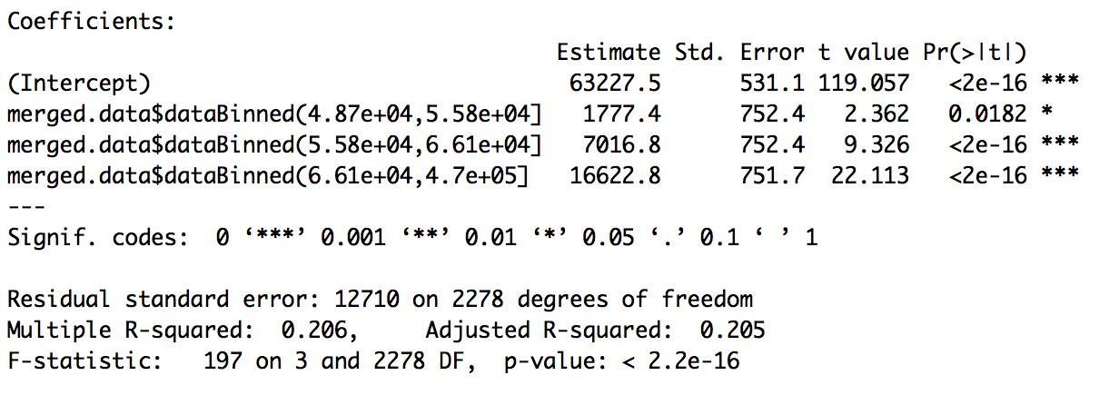

Binned IRS data used to predict Lending Club income winsorized
Coefficients | Estimate Std. | Std.Error | T Value | Pr(> | t | )
( Intercept ) | 63227.5 | 531.1 | 119.057 | < 2e-16
IRS DataBinned - 2Q | 1777.4 | 752.4 | 2.362 | 0.0182
IRS DataBinned - 3Q | 7016.8 | 752.4 | 9.326 | < 2e-16
IRS DataBinned - 4Q | 16622.8 | 751.7 | 22.113 | < 2e-16
Multiple R-Squared | 0.206

